Sub Cash and Late fees

Stakeholder – Jason Hershey
POC - Javier
For ticket reference :
ASCC: PCC - Subsequent Cash report
Status: |  | Pending - Customer
Ticket # |  | 297408
Company: |  | Asbury Communities
Contact: |  | Jason Hershey
Phone: |  | (717) 591-8374
Address: |  | 5285 Westview Drive  Frederick, MD 21703
 | 
  Jason Hershey
  24/02/2025 11:29 AM-

Good morning,
I need to request some assistance with pulling data out of PCC (data relay) for a report that is needed.
Prior – myUnity:
There was a custom report written that allowed us to pull this data. Basically, it was a cash report that provided details. Using the criteria for the report, it would allow us to: See when the cash was deposited, when it was posted to an account, to who’s account it was posted, to what “Payer” and most importantly, to what aging bucket (dates of services). This was 100% self-serve report in myUnity.
Current – PCC:
There is NOT a “boxed” report that provides this level of detail. After a number of communications with PCC, they do not have a report for this. They have pointed me / us to the data relay location to pull the data.
I’m requesting a ticket be opened to assist in pulling this data, as per the instructions provided by PCC (which follows this).
From: Jaymie Martinez <Jaymie.Martinez@pointclickcare.com>
Sent: Thursday, November 28, 2024 12:53 PM
To: Hershey, Jason <JHershey@Asbury.org>
Cc: Julissa Mariscal <Julissa.Mariscal@pointclickcare.com>
Subject: E023969 ASBURY RE: PCC reports / data assistance
Hi Jason,
As per our technical team, the data requested is available in Data Relay.
Please join the following views for the Cash Payments:
- View_ods_ar_batch (BatchType=’D’)
- View_ods_ar_transaction (TransactionType=’C’)
- View_ods_ar_applied_payment_history (JOIN ON TransactionID from View_ods_ar_transaction)
For Late Fees, this is dependent on how you enter late fees in our application. It’s most likely a charge code which can be found in view_ods_ar_transactions, and/or in view_ods_ar_recurring_transactions.
Please let us know if you have any questions.
Thank you,
Jaymie Martinez, PMP(she/her)
Project Manager, Enterprise
416-938-0586
From: Hershey, Jason (ASCC) <JHershey@Asbury.org>
Sent: Tuesday, November 12, 2024 12:11 PM
To: Jaymie Martinez <Jaymie.Martinez@pointclickcare.com>
Cc: Julissa Mariscal <Julissa.Mariscal@pointclickcare.com>
Subject: PCC reports / data assistance
"EXTERNAL EMAIL" – Always use caution when reviewing mail from outside of the organization.
Jaymie,
As per request.
We need to have a Subsequent cash report. We are in need of a report that we can run to show us cash posted in a period (month) and to what AR (aging) it was applied to.
Simple example of this: Run a report for payments posted 10/1/2024 – 10/31/204. Have the output provide details to the posting. To what payer, to what AR Aging bucket. Details should show all payment transactions, so if there is a return check, we want to see it. Or if we are simply moving cash around, one bucket to another. We are looking for all the detail to review.
This is needed for our audit as well as this is used on a monthly basis for me to track the performance of our collections staff.
We also are in need of details around late fees. My CFO is asking me for how much we have billed in late fees. I can provide that to him. He is also asking for the figure of “Open AR”, of that, how much are late fees (to the resident level). Lastly, he is looking for how much was paid (late fees). I can only find the fees billed, I’m unable to find any of the other information.
This is being asked for, due to the fact that we needed to change our entire process of late fees when we went to PCC. Prior, we deferred the revenue as well as the AR and only captured when paid. With PCC, all is captured as revenue and AR. And we have no way of monitoring, which we need.
Here is an example of a Sub cash report. I removed resident names. All pretty straight forward. The Pmt Tran date is the AR that it was applied to. So, this is showing cash received / posted in March and you can see how it was applied to older dates of service (and some current).
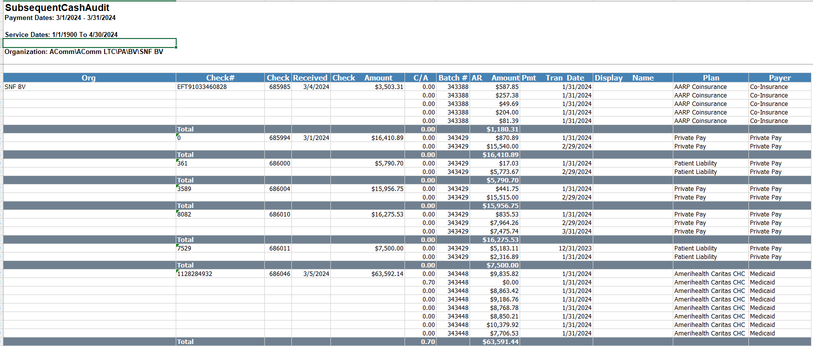
Jason Hershey
Director of Revenue Cycle Management

Views Created for Sub Cash and late fees

Environment – Dev and UAT
Cluster – acm-dwh-cluster
Database – dim
Views list:
dim.View_ods_ar_batch
dim.View_ods_ar_transaction
dim.View_ods_ar_applied_payment_history
dim.cashreportpayments
dim.cashreportlatefee

